**Breast Imaging Clinic Protocol**

**Before the subject arrival:**

1. **Hardware/software**
2. Fix the camera on the tripod by using the bolts in the side pocket of the black tool kit.  
   Make sure the level disk on the camera is well balanced (Bubble must be in the middle of the middle circle).

Tie the pink scarf around the back of the camera.  
Then set up the computer.

1. Plug in the following at least 30 minutes before imaging is to begin, to allow warmup
   1. Plug in camera power cable (AC adapter)
   2. Plug in camera output cable in the *TOP port (BASE #1)* at the back of the Black Box
   3. Plug in camera USB input cable
2. Plug everything else in: monitor and mouse (The wireless receiver stick is inside the mouse)… Power-up the computer.
3. Go through the software (see separate sheet) and verify that images are being acquired. **Be sure that AGC is OFF**.
4. Set up a new folder for each patient using their patient ID (Alison will provide it) in the given directory. This is where the images will be saved. See the attached software sheet.
5. **Camera noise**

Once the camera is set up, pay close attention to noise in the image itself and in the *right most end of the histogram*. If there is noise, keep moving the cables around until all noise disappears (do your best!). Make sure to do this before the patient comes into the room to save time.

1. **Chair and setup preparation**
2. Set up chair and **arm supports**. Have the two arm supports be at the same height
3. Position the red seat cushion
4. Position **back cushion** such that it supports the **upper back** of the patient, you need to tighten and tangle the straps to have the cushion stay high up on the back of the seat (See image below)
5. Position the **two side mirrors** on the poles of the arm supports. Using the red knob of the flex bars, lock the flex bar in a position to adjust the position and orientation of the mirrors. The mirrors must fully show the sides of the breast (See image below).
6. Adjust the **focus** as discussed in part 4.E, prepare the reference marks with tape for both the focus and rotation angles. This will save time when the patient comes.

**After the subject arrival:**

1. **Subject**

(She will already have been consented by the clinic staff)

1. **Welcoming the patient:**  
   Explain the procedure to the subject when she arrives: Imaging will take 15 minutes after she undresses and imaging starts, and she has to stay still for the entire time.
2. **Arm supports:**   
   With her clothes on, adjust the lateral (at the chair base) and vertical (use turn collar on support shaft) positions of the arm supports. Then adjust the elbow angle to a position that is comfortable for the subject.
3. **Tripod:**  
   Adjust the tripod height and camera position so that the full width of her chest nearly fills the field of view of the camera. Make sure the camera is leveled (bubble in the center)
4. **Side Mirrors:**

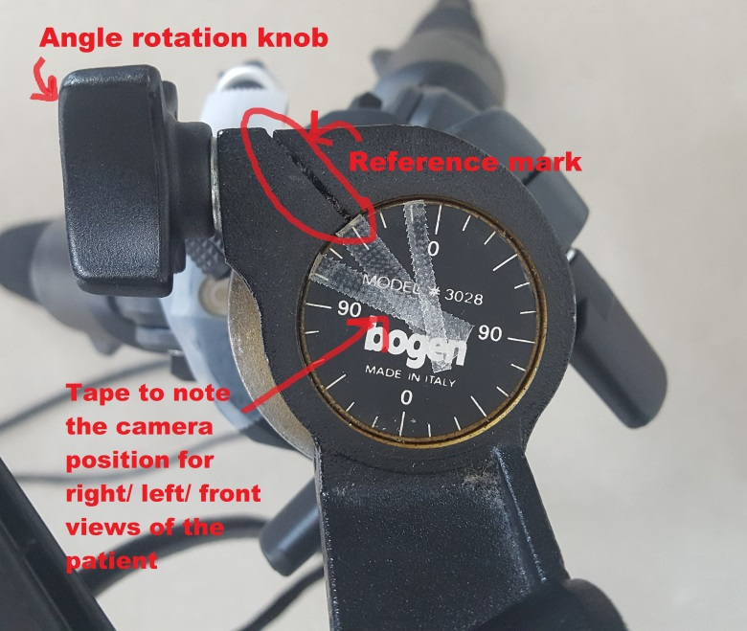Adjust the position of the mirrors, so that it shows the full side of the breast. Make sure the mirrors are not in contact with the patient. (See attached images for reference)

Rotate the camera and have it face the right side mirror (make sure the level bubble is still centered).   
  
Once a good position is set to show a full and focused view of the breast side, **note the angle with the reference line with a thin piece of tape** (As shown in the image)  
  
Repeat for the left side mirror, and note its angle against the reference line with another piece of tape.

Repeat the above for the front view of the patient.  
** Look at a sample image below

1. 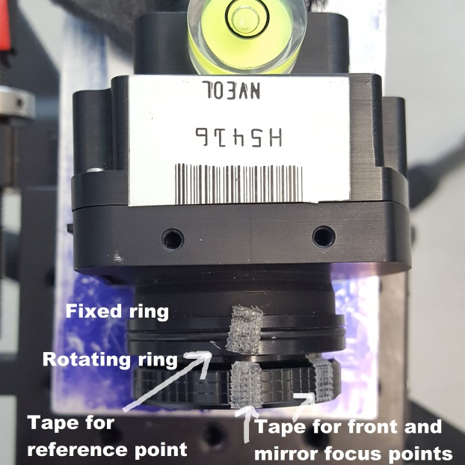**Focusing the camera:**
2. Ask the patient to hold a watch or bracelet as close as possible to her nipple or chest
3. Then **focus** the camera as best as possible on the edges of the watch,   
   **Do not touch the lens.**
4. Put a reference mark with a thin piece of tape on the outer non-moving ring of the lens. Then, put another thin piece of tape on the moving focusing ring to mark where you found the best focus and have it align with the reference tape.
5. **Focusing the camera on the mirrors**
6. Rotate the camera on the left side where you marked the position with tape.
7. Have the patient hold a watch or bracelet next to the side of their breast.
8. Focus the camera on the breast reflection on the mirror (not on the patient!), use the watch to help find a good focus.
9. Mark the new focus location with a piece of tape on the moving focus ring of the camera and have it align with the reference tape.
10. Repeat for the other mirror

* The results are two reference marks for the focus; one for the front view, the other for side views

1. **Camera to patient distance:**  
   Measure the distance between the patient and the camera with the measuring tape, and write it down in the lab notebook.
2. **Imaging a ruler:**
3. Ask the patient to hold a ruler from the middle point (provided in the black bin) **horizontally** as close to her chest as she can, and at approximate nipple height.
4. Make sure the sides of the ruler are shown clearly in the image and are not obscured by the background (See sample image below)
5. Take one image snap of the patient holding the ruler.  
   **Save the image with the patient ID, for example, *IRST012_ruler*  
   **See the software sheet on how to take one image only with the camera.
6. **Before asking the patient to undress**, double check the following:
7. The mirrors are still in good position
8. The focus reference marks are labeled
9. The rotation angles for the camera are labelled
10. The setup on FrameLink Express for taking the first side mirror image is prepared (this is to save time of cooling after the patient undresses)
11. *Ask if the patient is wearing a high-waist pants/skirt or if she’s wearing nipple piercings. Kindly ask the patient if she can push down her pants/skirt below her navel when she undresses later, and if she can remove her piercings.
12. **Ask the patient to remove her upper clothing**, and do the following as quickly as possible:
13. Let her sit back on the chair and position her arms on the already-adjusted supports so that they are away from the sides of her breasts. Ask the subject to remain as still as possible.
14. As quickly as possible, perform these steps:
    1. Readjust the tripod/mirrors if necessary
    2. Fix the histogram on FrameLink Express to adjust the display

Then do the following:

* 1. Readjust the focus to the reference mark of the mirror and take **one image** of the **right side mirror**, using the tape mark you set as a reference in part F.

- Save the image with the patient ID, for example, *IRST014_Right_min0*

* 1. Take one image of the left side mirror

Save the image as *IRST014_Left_min0*

* 1. Put the camera pack to the frontal view and adjust the focus based on the reference mark made in part E. Then, i**mmediately begin imaging** for 15 minutes   
       
     Feel free to talk with the subject if she wishes, as long as she doesn’t move.

1. **Recording Data:**  
   Make sure the data is being recorded in the designated folder by going to *Documents*, open *BreastIR* and then open your subject specified folder. Check that the images are being saved there and 60 images are added every 30 seconds.
2. Once 15 minutes are over:   
   Take **two more images of the mirrors** and save them as:   
   *IRST014_Right_min15* and *IRST014_Left_min15*
3. After imaging is complete, check to be certain that the data have been recorded on the hard disk, and then copy the data to the USB stick.   
   Tell the subject that “we are finished”, ask her to re-dress, and **thank her for her participation.**
4. Wrap up – if there are no more subjects on this day, power down everything, disassemble, and return all pieces to the storage area (Allison will know where).
5. Bring the USB stick and notebook back to the lab.

Back cushion adjustments: 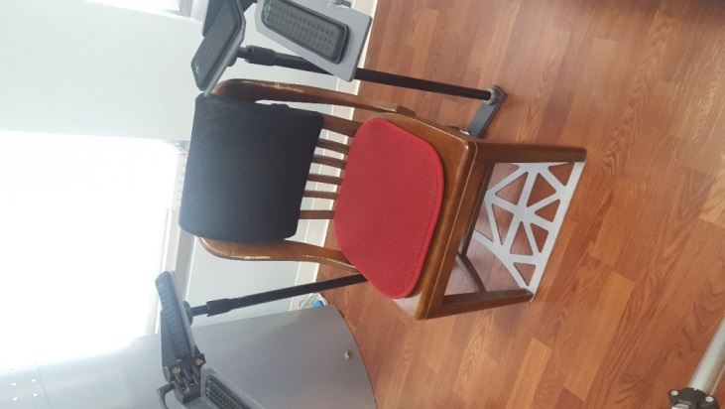 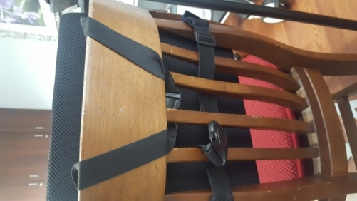

1. Volunteer 1: Sample mirror images + ruler

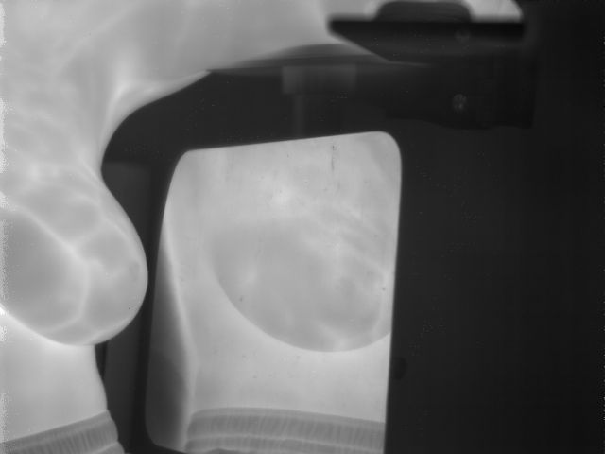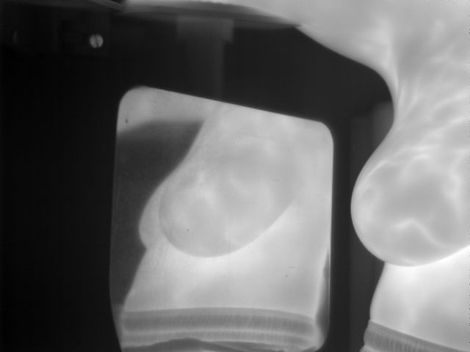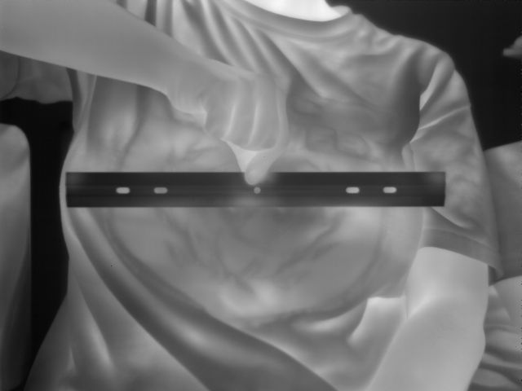

1. Volunteer 2: Sample mirror images

